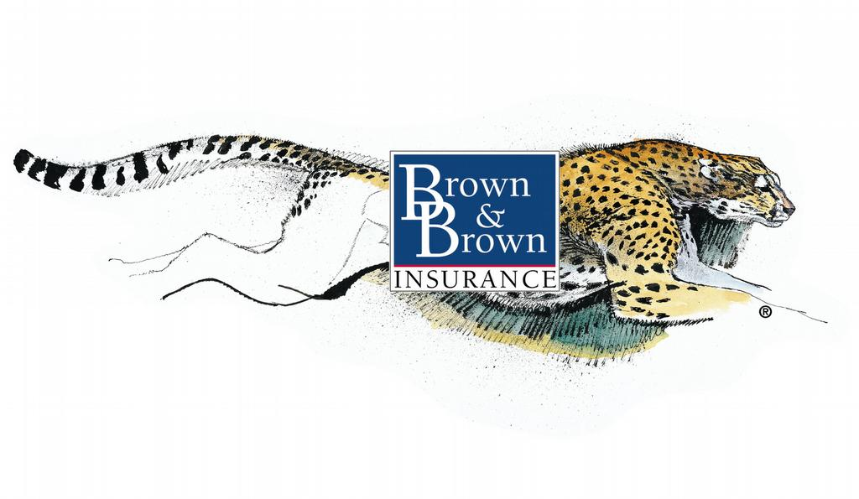
Brown & Brown of New Hampshire

Executive Summary
Prepared for:
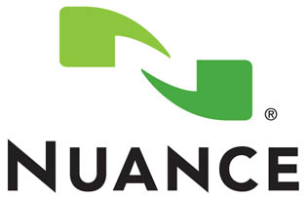

Presented by:
Dave Branning, AAI

Director of Marketing
Table of Contents
- Introduction ………………………………………………………………………...3
  - Scatter Analysis…..……………………………………..….………….3
- Errors & Omissions
  - What is it? .………….…………………………………………..……….4
  - Why do I need it? ..…………………………….………………..……4
  - Claim Examples .………………………………………….….……..…5
  - Recommendation ..……………………………………………..……6
- Employment Practices Liability
  - What is it? …..……………………………………………………..……7
  - Why do I need it? …………….………………………………..……..7
  - What it covers ……………………………………………………..……8-10
  - EPLI Exclusion ….…………………………………………………....…11
  - Additional Information ….…………………….……………..…...12
  - Recommendation ….………………………………………..….……13
- Protective Safeguards
  - What is it? ….…………………………………………………...……...14
  - Why is it important to understand? …………………………14
  - What you need to know....……………………………………..…14
  - Claim Examples ….…………………………………………….………15
  - Protective Safeguard Endorsement ….….……………..……16
  - Burglary & Robbery Safeguard ….……………………….…….17
  - Recommendation ….…………………………………………………18-19
- Back-up of Sewers and Drains Exclusion
  - What is it? …………………………………………………………………20
  - Why do I need it? ………………………………………………………20
  - Other Causes of loss ………………………………………………….21
  - Policy Exclusion …………………………………………………….…..22
  - Recommendation ………………………………………………………23
- Conclusion …..……………………………………………….…………….…………24

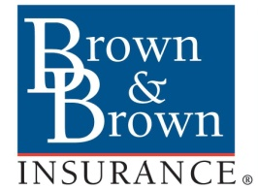

Brown & Brown, Inc. is recognized as one of the largest and most respected independent insurance intermediaries in the nation. With over 64 years of continuous service, Brown & Brown is ranked the eighth largest insurance intermediary in the world by U.S. business by Business Insurance magazine as of July, 2011. Brown & Brown’s reach includes over 37 states and offers insurance programs and services through their 200+ Retail, Brokerage, National Programs and Services offices throughout the country.
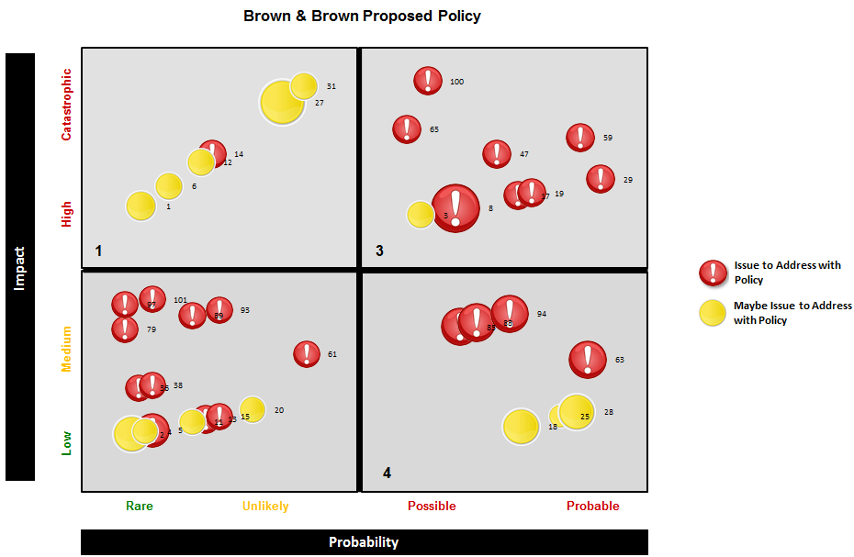
Our process is designed to identify areas of improvement within insurance policies to make certain your premium dollars are maximized. We reviewed approximately 150 different areas within your policies and found approximately 25 potential areas of improvement. The 4 areas we are discussing today and highlighted on the following pages may not be any more important than another.
(Disclaimer: Please refer to the actual policies for terms, conditions and coverage)
OVERVIEW OF FINDINGS AND RECOMMENDATIONS BASED UPON PRELIMINARY ANALYSIS
Errors & Omissions (E&O)
What is Errors & Omissions?
Errors and Omissions is a type of insurance designed to cover providers of technology services or products. For example, data storage companies and website designers provide technology services, while computer software and computer manufacturers offer technology products.
Tech E&O policies cover both liability and property loss exposures. Major liability insuring agreements include losses resulting from: (a) technology services, (b) technology products, (c) media content, and (d) network security breaches. Key property insuring agreements provide coverage for extortion threats, crisis management expense, and business interruption.
Tech E&O insurance is often confused with cyber and privacy insurance. In contrast to tech E&O coverage, cyber and privacy insurance is intended to protect consumers of technology products and services. Nevertheless, cyber and privacy insurance policies do offer a number of the same insuring agreements as tech E&O policies.
Why do I need E&O?
To put it very simply, everyone makes mistakes. Even with the best employees and the best risk management practices in place, mistakes will be made. No one is perfect.
By not purchasing E&O a company can be taking a serious financial risk. These types of losses are not covered under a general liability policy. Even if you are not at fault, litigation is both time consuming and expensive.

Claim Example #1
Description of Event
A software company was sued by one of its prominent customers after using the company’s cost-estimating software. The customer alleged that a defect in the software caused several projects to be underbid. After a lengthy investigation, the software itself was found to have functioned perfectly, and the error was on the part of the user.
The customers eventually dropped the case, but only after considerable legal expenses were incurred by the software company.
RESOLUTION
The claim was valued at $175,000.
Claim Example #2
Description of Event
A company provided timekeeping hardware and software to its customer. The software didn't function correctly; it failed to maintain employee hours worked and correctly apply the hourly and overtime rate of pay. The failure resulted in over/underpaying employees and the need to replace the timekeeping clocks. The customer sued the provider of the hardware and software.

Resolution
The claim was valued at $440,000.
Claim Example #3
Description of Event
A software developer was sued in French courts for failing to deliver an operational version of a software system. The plaintiff alleged that the system sold and installed was not compatible with its mainframe systems, despite assurances to the contrary. The plaintiff sued for recovery of consequential damages.
Resolution
The claim was valued at $600,000.
The Brown & Brown Recommendation
Plain and simple, mistakes happen. E&O insurance provides coverage that your commercial general liability insurance policy does not. It's critical that your company have errors and omissions coverage to protect you against liabilities not covered by your general policy, such as: contract performance disputes, programming errors, and any other issues associated with professional liability. Providing technology services and products to your customers when you don't have errors and omissions insurance is putting yourself in a dangerous position; you are taking on risk without the proper insurance protection should a mistake (or allegation of a mistake) happen. Don't put yourself and the company at risk! Get the technology errors and omissions insurance coverage you need.
As a technology company, you're in the business of innovation, and innovating means taking risks. In the quickly changing environment of today's technology industry, protecting your company against constantly evolving threats is imperative. The growing number of occurrences of security breaches and data theft makes network security insurance coverage an important part of your company's technology errors and omissions policy. As the importance of online social networking in technology companies' reputation management continues to grow, cyber liability insurance is increasingly important as well. At Brown & Brown, our experience in the technology insurance market means that we understand the exposures that your company encounters as well as the insurance contracts that will offer the best protection against your specific risks.
Technology companies face unique liabilities, so specialized insurance coverage is important. No matter what size your technology company is or what part of the industry your operations involve, Brown & Brown can find the errors and omissions insurance policy that meets your needs at a competitive price. We will work with you to quote an insurance policy that includes all of the technology coverage’s you need.
As you work to grow your technology business, don't let concerns about errors and risks slow your progress; know that your company and its innovations are protected by the right errors and omissions insurance policy. The same technology errors and omissions insurance coverage isn't suitable for every company, so let Brown & Brown find you the policy that's right for you.

Employment Practices Liability (EPLI)
What is Employment Practices Liability?
EPLI is a type of liability insurance covering wrongful acts arising from the employment process. The most frequent types of claims covered under such policies include: wrongful termination, discrimination, sexual harassment, and retaliation. In addition, the policies cover claims from a variety of other types of inappropriate workplace conduct, including (but not limited to) employment-related: defamation, invasion of privacy, failure to promote, deprivation of a career opportunity, and negligent evaluation. The policies cover directors and officers, management personnel, and employees as insured’s.
Why do I need EPLI?
Cases against employers are on the rise. It is estimated that three out of five firms will be sued by an employee. Companies are finding that they are vulnerable from the pre-hiring process through the exit interview, even if the employee was never hired, or only at the company a matter of days.
It can happen to any company. We have all experienced it. It could be a joke told in the break room, an employee you had to fire, a “friendly” programmer, or that person you chose not to hire. Every employer faces the reality that it will be the target of legal action from past, present and prospective employees. Even if the claim is groundless or fraudulent, the defense of a suit can be expensive in time, resources and financially.

What EPLI Covers
Wrongful Termination Claims:
More than any other aspect of the employment relationship, the discharge of an employee has the potential to result in litigation. EPLI policies cover claims by former employees alleging that he or she was wrongfully terminated. Some policies also cover claims of "constructive discharge" by employees who claim that they could no longer tolerate the work environment and were compelled to resign or retire.
Discrimination Claims:
Policies can also cover claims by current, former or prospective employees who charge that they were the victim of employment-related discrimination on the basis of any federal, state or local law that prohibits discrimination by employers.


Sexual Harassment:
Coverage for sexual harassment claims against your company, including claims against supervisors and fellow employees can be included. In addition, the policy can cover all categories of sexual harassment as currently defined by the Equal Employment Opportunity Commission.

Whistleblower Claims:
Policies can also cover claims by employees who charge that they were the subject of an adverse employment decision solely because they disclosed an unfair or illegal practice by the employer. This is one of the few policies to specifically cover whistleblower claims. Sometimes these matters are referred to as "Section 132".
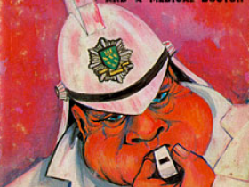
Wage & Hour Claims:
The FLSA sets the minimum wage and maximum hour/overtime requirements. The Wage and Hour Division of the Department of Labor manages the administration of the FLSA. FSLA actions are frequently NOT covered without specific EPLI insurance policies.

Other Employment-Related Claims:
Other additional causes of action which are alleged in employment litigation, such as libel, slander, or other defamation, invasion of privacy, mental anguish, infliction of emotional distress, loss of consortium, assault, battery, breach of contract, negligent hiring, supervision, promotion or retention in connection with any other employment-related claim, can often be covered.


EPLI Coverage Exclusion
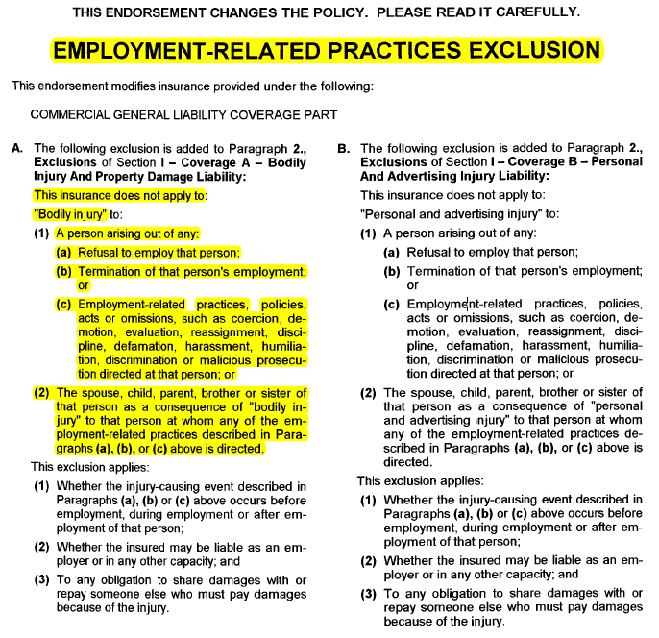

Additional Information
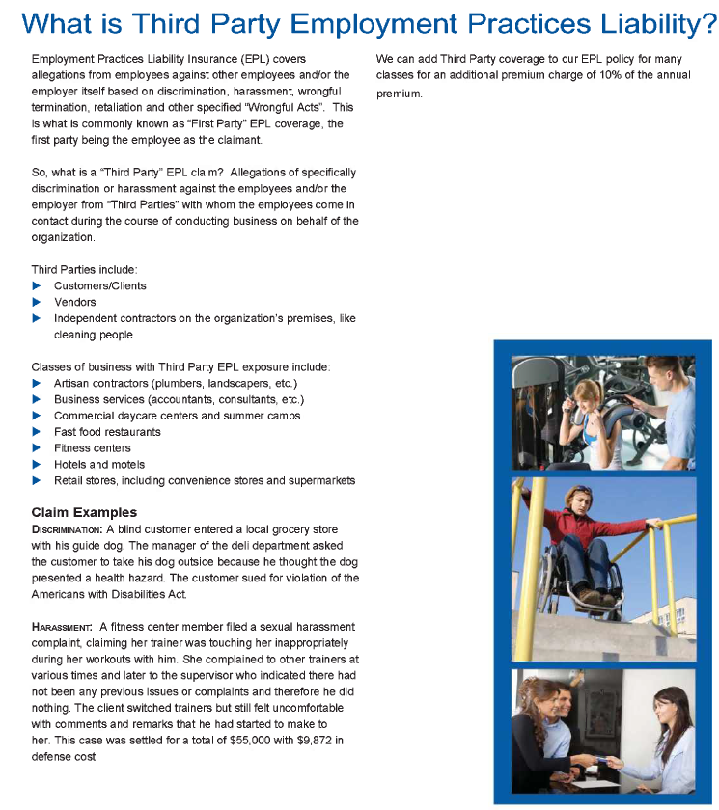
The Brown & Brown Recommendation
All companies, regardless of size, should look to their personnel policies as the first line of defense against both the number and severity of employment-related claims. EPLI coverage is another valuable tool in a comprehensive risk-management arsenal.
EPLI policies are written on a claims-made basis. This simply means that covered claims must be reported to the insurance company while the policy is in effect, or within an extended period specifically described in the policy. In addition, the event leading to the claim must have occurred either on or after a specific date - typically the date when the EPLI policy commenced. Some insurers offer extended retroactive dates or full protection for earlier claims, but you should be sure you understand these terms.
The cost of EPLI coverage will vary based on the type, size and risk profile of your business. The insurance company may also want to see your written personnel policies to help them determine the risk and cost of your EPLI policy.
Following are additional factors that affect the value and cost of EPLI coverage. It is important to review these exclusions and coverage limitations when evaluating your policy:
- You can generally purchase EPLI coverage with limits ranging from $1 million to $25 million.
- Most employment practices liability insurance policies include a deductible. In addition, the cost of legal defense is typically included in the aggregate insurance limits, along with the costs of judgments and settlements.
Since this type of coverage is excluded from your insurance policy, this add-on endorsement is critical in order to be fully protected.

Protective Safeguards
What is a Protective Safeguard?
A property insurance endorsement that makes it a condition of coverage that the protective safeguards cited in the endorsement (such as an automatic sprinkler system or night watch guard) be in operation at all times except when the insurer has been notified of the impairment in protection. Failure to maintain the protective safeguards in good working order or failure to notify the insurer of even a temporary impairment in protection suspends coverage until the protection is restored.
Why is it important to understand?
Do not be fooled. The policyholder is not the one being protected by a protective safeguards provision.
A protective safeguards provision allows the insurance company to deny coverage if certain conditions are not satisfied at the time of loss. For example, if the fire sprinkler system does not operate properly, there is no coverage. If the burglar alarm system does not go off, there is no coverage. If the smoke detectors do not work, there is no coverage, and so on.
It is not always a bad thing, but you must be aware that it is on your policy or claims may be denied.
What you need to know
A premium discount or credit may be given if the property insurance policy includes a protective safeguards endorsement. A protective safeguard may be in the form of a service contract with, for example, a security company or private fire department, or it may consist of or be supplemented by a mechanical or electronic system.
After identifying particular protective safeguards, the endorsement form states: "As a condition of this insurance, you, Nuance, are required to maintain the protective devices or services listed in this endorsement."
In other words, the insured has at least two additional duties if the policy includes a protective safeguards endorsement: the duty to notify the insurer if the insured learns of any "suspension or impairment" of any device or service listed in the endorsement, and the duty to "maintain…in complete working order" any device or service that is listed in the endorsement and over which the insured has control.
Claim Examples
Example #1
In Burmac Metal Finishing Co. v. West Bend Mutual Insurance Co., an Illinois appellate court said in 2005 that a property owner's intentional capping of between three and 19 automatic sprinkler system heads out of 600 in an industrial building, without notice to the insurer, constituted failure to maintain the system and justified a denial of coverage for a fire and explosion.
Example #2
In Goldstein v. Fidelity & Guaranty Insurance Underwriters, the Seventh U.S. Circuit Court of Appeals ruled in 1996 that although an insurer was obligated to pay for fire loss that occurred during a period when the protective safeguards endorsement had been waived due to an error by the insurer's agent, the insurer was justified in denying coverage for subsequent loss due to the owner's failure to restore a nonfunctioning sprinkler system, as required by the endorsement.
Example #3
A California appeals court said, in a 2006 case known as Y2K Textile, Inc. v. Lexington Insurance Co., that the insurer had properly denied coverage for fire loss where the protective safeguards endorsement required the insured to maintain a contract with a duct cleaning service and the insured never obtained such a contract.
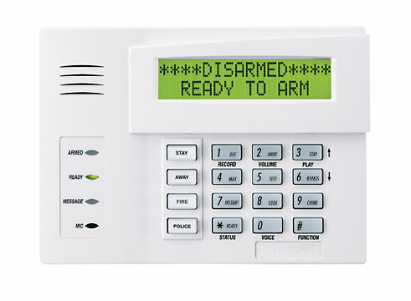
Protective Safeguard Endorsement
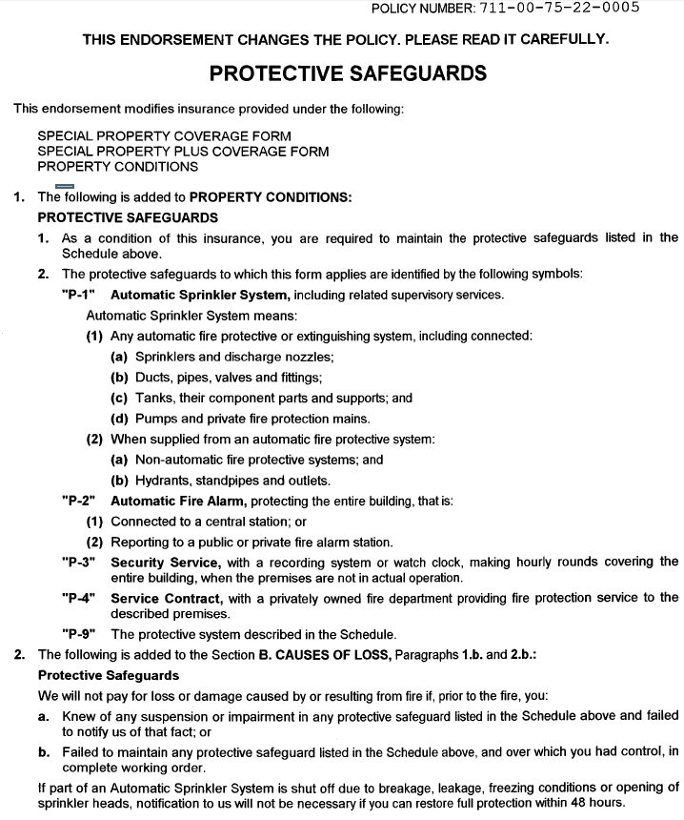
Burglary and Robbery Protective Safeguard

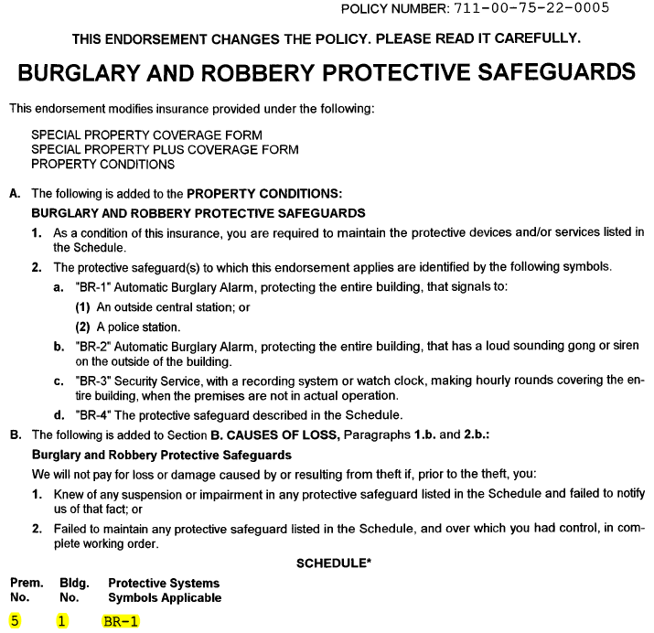

Brown & Brown Recommendation
What is a business owner to do with this information? Although a brief summary cannot offer advice that is sound in all circumstances and all jurisdictions, here are some practical considerations:
Identify and understand applicable endorsements
Property owners (and this term is used to include tenants whose leases give them equivalent risks and obligations) should make sure they know whether the applicable insurance policy includes a protective safeguards endorsement. If it does, they should also be sure they have an accurate understanding of what is required by the terms of the endorsement.
Weigh savings against risk
If the existing property insurance policy includes a protective safeguards endorsement, the party responsible for obtaining or maintaining that policy should investigate the premium savings provided by that endorsement. Affected parties should weigh the savings against the potential risk that a claim for fire loss may be denied if the particular safeguards do not function properly.
Be prepared to give required notices promptly
Insured’s under property insurance policies with protective safeguards endorsements should review the notice provisions of their policies to determine how and to what address notices are to be given. Insured’s should make sure this information is communicated to those with operational responsibility for each insured property so notice can be given, when appropriate, without delay.
Keep detailed maintenance records
Anyone with contractual or practical responsibility for maintaining systems, devices and contracts should keep detailed records of the nature, timing and results of maintenance activities. As noted earlier, it is not clear that maintenance efforts will be sufficient to satisfy requirements of a protective safeguard endorsement if a maintenance failure on a single, critical occasion leads to a failure of a system or device, but an insured is clearly on stronger ground if it can show a consistent pattern of maintenance.
Recommendation (Continued)
Consider how listed systems might become impaired
Recalling that "impairment" as well as "suspension" of a device or service may require notice to the insurer, any party with an interest in the availability of fire insurance coverage should consider how, as a practical matter, each listed system, device or service might be impaired, and how non-impairment may be demonstrated.
Watch for analogous requirements
Protective safeguards endorsements are sometimes issued with respect to risks other than fire, including burglary, theft and damage to construction work in progress. Those endorsements contain similar language and may present similar risks to insured’s. They deserve similar thoughtful attention.

Back-Up of Sewers and Drains - Excluded
What is this exclusion?
Just because you have flood coverage does not mean that back up of sewers and drains is covered. These are very different types of occurrences and each require specific insurance coverage. A flood involves rising waters, such as those caused by rain, melting snow, or overflow of a river. Sewer or drain backup, results from water that causes damage to your commercial property as a result of a sewer or drain backup. The Back-up of Sewers and Drains exclusion eliminates coverage for water damage caused by sewer or drain back-up.
Why do I need it?
Sewer back-up occurs when the city or municipal drainage system overflows and sends water back through the pipes and into your building. This may happen for a variety of reasons, but the most common is a great deal of water from rainfall or snow melt overwhelming the system. It can also be a result of a failure on the part of a sump pump or other system designed to deal with excess water. The water and sewage can come from various sources including a septic tank, sewer or storm drain.
Sewer back-up can result in a great deal of damage to buildings, including the development of mold problems and of course bacteria from sewage that has entered the home. It requires immediate proper clean-up that can be very expensive as well as can result in damage to carpets, walls, furniture and other personal property that will be costly to replace.
Other Causes of Sewer Back-Up
Blockages due to Tree Roots: Shrubs and trees seeking moisture can make their way into sewer line cracks causing extensive damage. They may start out small, getting into a small crack in the pipe; but as the tree or shrub continues to grow, so does the root. Tree roots can enter the service pipe at joints and cause blockages. They can also travel a long way, and roots from different types of trees act differently. If you suspect that city trees are responsible for sewer line damage, your plumber can contact the city and samples of the roots will be used to help identify the trees and who is responsible for cleanup. Sometimes a blockage is the result of a combination of city and private trees. In this case costs are split between the city and property owner.
Sanitary Main: A blockage can occur in a city sanitary main. If the blockage is not detected in time, sewage from the main can back up into homes and businesses through floor drains. Usually this happens slowly, giving the owner time to call a licensed plumber to assess the damage. If water is entering your basement at a rapid rate, call the city public works office and report the problem immediately so that a city operator can investigate.
Back-up of Sewers or Drain Exclusion
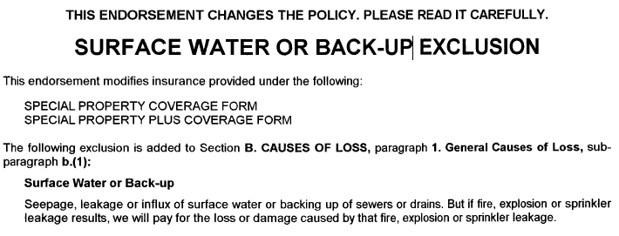
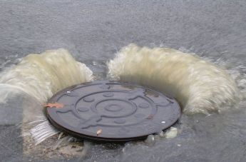
Recommendation
Add coverage for an appropriate limit to properly cover this exposure. You should have proper coverage for excessive rain seepage, blockage and back up of pipes. This coverage is usually a nominal premium; let’s discuss proper values for your protection. A sewer backup can lead to disease, destruction of your valuables, damage to your house or business, and can even result in electrical malfunctions.
Conclusion
This Document was respectfully presented as a summary of coverage gaps discovered by Dave Branning of Brown & Brown Insurance Company of New Hampshire. Coverage summaries provided herein are intended as an outline of coverage only! And is not a substitute for the actual policies that will be issued. In the event of a loss, all terms, conditions and exclusion of the actual policies will apply. If we have determined during this Insurance Coverage Review that your current broker has not fulfilled his professional responsibilities to protect your company assets, my final recommendation is that your company move to fire your current agent and hire Dave Branning as your Broker of Record.



